Block Storage with Amazon EC2 Instance Store and Amazon EBS
- Need for storage: Every EC2 instance requires block storage — used either as a boot volume or a data volume.
- Two main storage types:
- Instance Store (internal storage)
- Amazon Elastic Block Store (EBS) (external storage)
Instance Store
- Directly attached: Storage is physically connected to the host server.
- High performance: Very fast due to its direct attachment.
- Non-persistent: Data is lost when the instance is stopped or terminated.
- Best for temporary data like caches or buffers.
Amazon EBS
- Network-attached storage: Separate from the EC2 instance, similar to an external hard drive.
- Persistent storage: Data remains intact even if the instance is stopped or terminated.
- Flexible attachment:
  - Can attach/detach to/from different EC2 instances in the same Availability Zone.
  - Supports EBS Multi-Attach for connecting to multiple instances (depending on type).
- Secure access: Only attached instances can communicate directly with the EBS volume.
- Use case: Ideal for workloads requiring data persistence.

EBS Volume Types
- SSD-backed volumes: Optimized for performance and IOPS.
- HDD-backed volumes: Optimized for throughput and large sequential workloads.
Backup and Recovery
- EBS Snapshots:
  - Serve as incremental backups stored redundantly.
  - Allow recovery by creating new volumes from snapshots if data loss occurs.

Amazon EC2 instance store
- Temporary storage: Amazon EC2 instance store provides ephemeral block-level storage for EC2 instances.
- Physically attached: Data is stored on disks physically connected to the host computer.
- Lifecycle tied to instance: When an instance is deleted or stopped, the instance store data is lost.
- High performance: Offers fast, locally attached storage.
- Best use cases:
  - Applications that replicate data across instances (e.g., Hadoop clusters).
  - Temporary data such as buffers, caches, scratch data, and other frequently changing content.
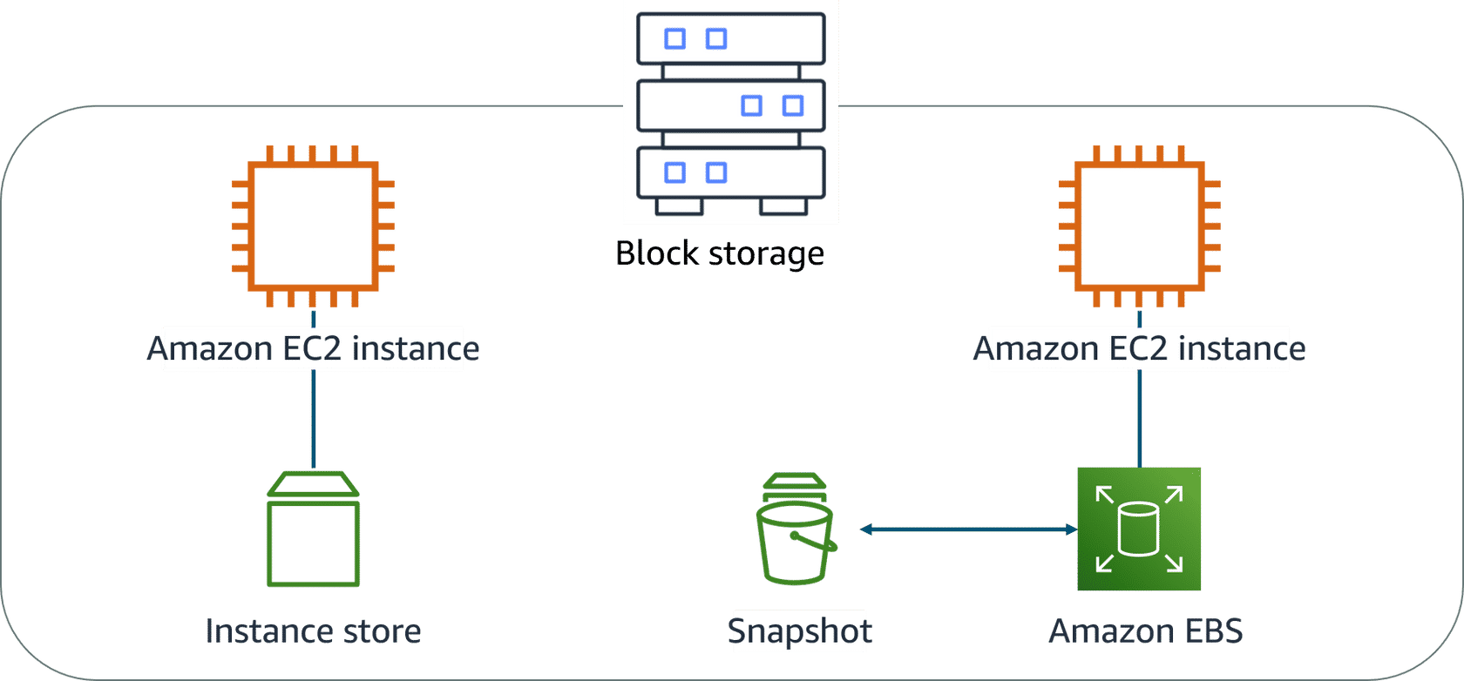

Amazon EBS
- Block-level storage: Amazon EBS provides attachable block storage for EC2 instances, similar to an external drive for a laptop.
- Detachable: An EBS volume can be detached from one EC2 instance and attached to another in the same Availability Zone.
- Persistent: Data remains safe and separate from the instance — if the instance fails, the data is still retained on the EBS volume.
- Size-limited: Each EBS volume has a maximum storage limit, similar to a fixed-capacity external drive.
- 1-to-1 connection: Most EBS volumes can be attached to only one EC2 instance at a time, maintaining a dedicated connection.

Scaling Amazon EBS volumes
Scale EBS volumes in two ways.
- Increase volume size
- Volume size limit: Amazon EBS volumes can be increased up to a maximum of 64 TiB.
- Expandable storage: You can increase the size of an EBS volume as long as it does not exceed 64 TiB.
- Example: A 5-TiB io2 Block Express volume can be expanded incrementally up to 64 TiB.

- Attach multiple volumes
- Multiple volumes: You can attach multiple EBS volumes to a single EC2 instance.
- One-to-many relationship: Each EC2 instance can have many EBS volumes attached.
- Flexible attachment: Volumes can be added during instance creation or afterwards.
- Scalable storage: Enables increased storage capacity for your instance as needed.

Amazon EBS use cases
- Operating System
- Database
- Enterprise application
- Big data analytic engines.

EBS volume types:
- SSD (solid-state drives) - Optimized for transactional workloads with frequent small read/write operations.
- HDD (hard-disk drives) - Optimized for large streaming workloads requiring high throughput.
Benefits
- High availability
- Data persistence
- Data Encryption
- Flexibility
- Backup
EBS Snapshot
- Backup necessity: Always back up EBS volumes to prevent data loss.
- EBS snapshots: Incremental backups that save only the blocks that have changed since the last snapshot.
- Example: If a 10 GB volume has 2 GB modified, only 2 GB is saved.
- Redundant storage: Snapshots are stored redundantly across multiple Availability Zones in Amazon S3.
- Managed in EBS console: No direct interaction with S3 is required; snapshots are handled via the Amazon EBS console.
- Volume restoration: Snapshots can be used to create new volumes, either in the same or a different Availability Zone.
- Exact copies: New volumes from snapshots are identical to the original volume at the time of backup.

Resources
(opens in a new tab)For more information, see the following resources:
- AWS user guide: Amazon EC2 Instance Store(opens in a new tab)
- AWS user guide: Amazon Elastic Block Store (Amazon EBS)(opens in a new tab)
- AWS FAQs: Amazon EBS

